The ‘Trial’ of Oliver S. Munsell–an exposition
by Robert Bray

The first indication of serious trouble at Illinois Wesleyan University came in the form of a ‘communication’ from the president, Oliver S. Munsell, to the executive committee of the university’s Board of Trustees: ‘Dear Brethren: I fear it to be my painful duty in view of the present unhappy condition of affairs in the University affecting my usefulness and acceptability [?] to ask to be relieved from and after tomorrow, Friday, from [sic] all official duties until the annual meeting of the Board next June.’ On Saturday, Feb. 22, 1873, the executive committee met in extraordinary session to consider President Munsell’s request to be suspended from administration and teaching for the remainder of the spring term. Though the committee granted his wishes, nothing in its minutes hints at what the ‘unhappy condition of affairs of the University’ was, nor what might be Munsell’s involvement in the problems.
But the nature of his difficulties became starkly and publicly clear on Tuesday, Feb. 25. The Chicago Tribune on that day ran two ‘special dispatches’ from unknown correspondents, one in Springfield IL and the other in Bloomington:

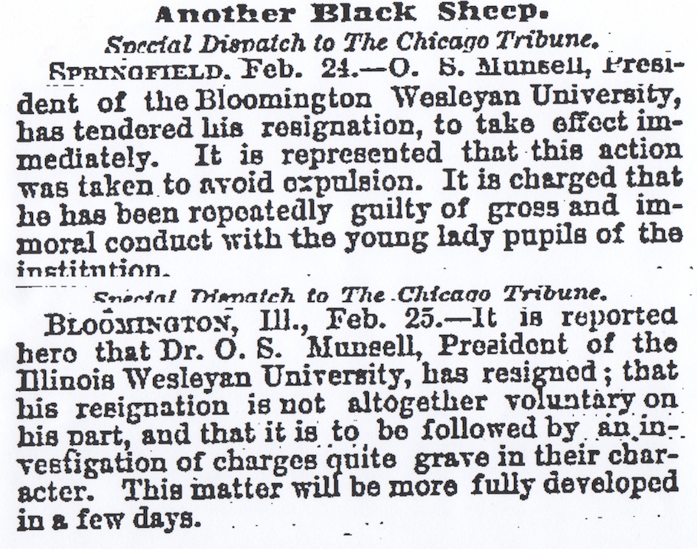

These accusations were such as to be libelous if false, criminal if true (‘criminal conversation,’ or adultery). Munsell immediately replied in a letter (dated Feb. 27; pub. Mar. 1) to the Tribune in which he denied that he had resigned the presidency and was not charged with ‘criminality.’ The letter also included resolutions of support from four faculty members:

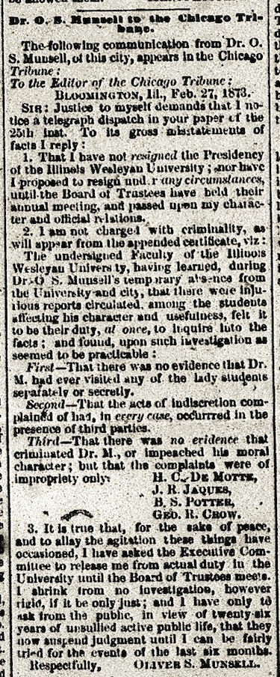

Then on Fri., Feb. 28, the local Weekly Pantagraph ran the following article, here given in transcription (note: the weekly edition was mainly a digest of news from the Daily Pantagraph, but in this case the daily had not noticed the Munsell affair):

‘For a week past, the city has been filled with rumors that Rev. Dr. O. S.
Munsell, President of the Illinois Wesleyan University, was guilty of
criminal indiscretions with some of the female pupils of the University.
We have refrained from saying anything on the subject until we could
obtain definite information concerning it, knowing that it was a charge
that involved not only Dr. Munsell’s reputation, but also, to some extent,
the good name of the University. From what we consider an entirely
reliable source of information, we learn that the most that is alleged
against Dr. Munsell is that he was somewhat profuse in his attentions
to some of the ladies, and that he kissed them rather too frequently.
Nothing of a criminal nature is alleged against him by any one connected
with the students or faculty. An investigation of the charges will at once
take place, and the results made known. Dr. Munsell, who is known to
be naturally rather demonstrative in his demeanor towards ladies, asserts
his entire innocence of any evil intention or improper acts. He is now,
we believe, absent from home. He has been President of the institution
for sixteen years, during which time he has labored incessantly for its
prosperity, and has donated to it more than he has received in salary.
His relations with the faculty have been uniformly friendly.

The University is an institution that Bloomington is proud of, and every
citizen of the city is zealous in upholding it. It is in the hands of able and
trustworthy men, and is universally regarded as an honor to the city and
the State. Ladies were first admitted as pupils about two years ago, and
now about forty lady pupils are in attendance. Dr. Munsell has been
relieved of his classes, and is, just at present, not on duty. He is still President,
however, and he will probably remain so until next June, when the Board
of Trustees meet.

Whatever may be proven against Dr. Munsell–and we are of the opinion
that nothing of a serious character can be shown–the continued prosperity
of the university [sic] cannot be affected by it in the estimation of those
who are familiar with its affairs. It numbers among its trustees and faculty
several eminent men, who have by strenuous exertions built up a noble
institution in Bloomington. Many of our citizens are graduates of the
university [sic], and the whole city feels deeply interested in its welfare.
We trust the evil tongue of slander will not pursue these charges any
farther, until the result of the investigation is known.’

On the 26th of February, the executive committee met at the office of long-term trustee John Magoun. There could be but one agenda item: what’s going on, Dr. Munsell? ‘Prof. Jaques. . . gave a statement on behalf of the Faculty of which complaints have been made and then and there Dr. Munsell replied giving explanations of the matters complained of. . . .’ The minutes do not detail what the charges were, or how Munsell explained his involvement in them. But given the damaging publicity, a public response to the charges was imperative. This document the committee intended to draw up on the morrow, but ‘on account of the illness of the chair’ (Charles W. Holder) that didn’t happen. In fact, the executive committee did not again meet until a week later, Mar. 6, 1873 (at the office of trustee O. T. Reeves). They came to the following resolution:

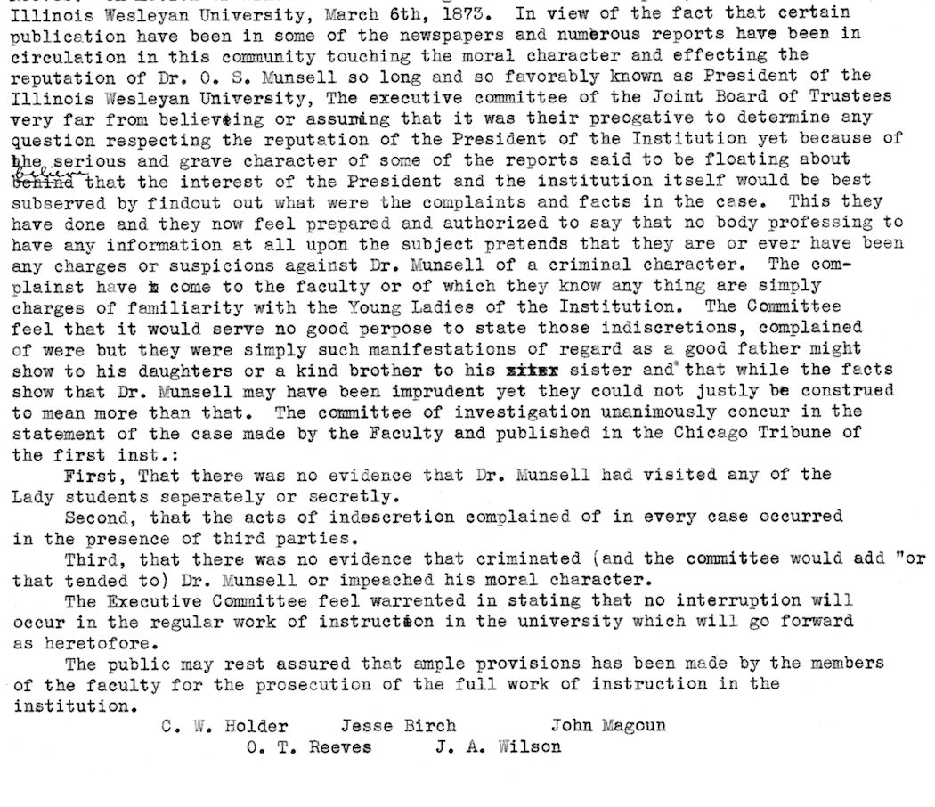
The executive committee first intended the above as a public statement that would put the matter to rest (especially in view of Munsell’s being exonerated of ‘criminality:’ ‘there was no evidence that criminated (and the committee would add “or that tended to”. . . .)). So the members at first decided to publish the statement, then, strangely, reversed themselves–no reason given.
The annual meeting of the Board of Trustees and Visitors ordinarily took place during the university’s commencement week, always in June. Presumably, at that meeting the executive committee would report on the Munsell matter. But the calendar was abruptly modified: there would be a meeting of the full board and visitors just as soon as everyone could be convened. No information regarding this change is to be found in the trustee minutes, which move directly from the Mar. 6 meeting of the executive to Mar. 19, when the special board and visitors meeting began. Why or by whom an immediate session had been demanded is unknown.
Since this extraordinary gathering would turn out to be the ‘trial’ of Oliver S. Munsell on charges of moral turpitude, it may be helpful to describe how it was organized and conducted. The Methodist Episcopal Church, Central Illinois Conference, had acquired what we might call ‘majority ownership’ in Illinois Wesleyan University in 1856, when, in exchange for increased financial support, the church would thenceforth have a much greater say in how the institution was conducted. There would be six clergy elected or appointed from the Illinois Conference as visitors (and, after the Illinois Conference spun off territory to create the Central Illinois Conference, twelve visitors total). These visitors would attend the annual commencement exercises and the board of trustees meeting and then report to their respective conferences. While the visitors may not have had votes in the trustees’ decisions–in the absence of roll-call votes in the minutes, this is not clear–they were generally present and surely had a voice in the deliberations. In addition to the visitors, there were several Methodist ministers on the board proper. So that, taken together, the MEC influence on the university was quite powerful.
According to the MEC’s Book of Discipline, whenever a member of a conference had charges of any sort made against him, he was ‘put on trial.’ The evidence was compiled, witnesses were called and examined, and both the complainant and the defendant had ‘attorneys’ to interrogate (and cross-examine) the witnesses. At the end of these proceedings, the minister being charged had the opportunity to speak. Then came the verdict: all members of the conference deciding the fate of one of their own by majority vote. In small matters, a reprimand; more serious, a suspension; most serious, expulsion from the ‘Methodist connection.’
Munsell’s trial followed these procedures pretty closely, with the significant exception that the jury consisted of the board of trustees, some of whom–and all of the executive committee–were not Methodist clergy (or perhaps even Methodists). Thus their professional training and values would not necessarily align with those of the MEC.
The trial opened at 10am on Wednesday, Mar. 19, 1873, in a hall of the new but still uncompleted ‘University Building.’ Charles W. Holder was in the chair, along with the other three members of the executive committee, eleven other trustees and six visitors. And, of course, President Oliver S. Munsell. The first order of business required the executive committee to report to the entire group the charges against the president. The trial would adjourn until 2pm to give the executive committee time to put its report in order. After hearing it, the board moved a committee of five to ‘make out charges and specifications’ and report the same. This group was given until re-convening at 7pm to get its work done.
But at the start of the evening session, the committee on ‘charges and specifications’ wasn’t finished, so made a ‘partial report’ only. This included ‘specification five’ (which would be one of ten charges; hereafter referred to as ‘spec. + number’). The board now ‘took it up,’ naming ‘Brother[s] [Jesse] Birch and [Owen T.] Reeves. . . to conduct the examination [of] the witnesses on the part of the Board.’ The witnesses called were four members of the university faculty: Jabez R. Jaques, G. R. Crow, B. S. Potter and S. S. Hamill. All testified. But what did they say and of what? This is, from a historical perspective, the most disappointing aspect of the minutes: no specification of what the specifications were and almost nothing of what the witnesses said. All we can infer concerning spec. 5 is that it probably centered around a university function, off-campus, both because these faculty were involved and, tantalizingly, Prof. Crow was asked about ‘the position of different parties on the rostrum at Durley’s Hall,’ a downtown Bloomington building popular for meetings social and serious. This is all we have for spec. 5, and it is more than we shall know of eight of the other ten. Only in spec. 7 will we get a real glimpse of what the charges were about.
Thurs., Mar 20, was the day for female student testimony. The evening before, a couple of board members had gone forth (presumably to sundry boarding houses around town) to tell the coeds that their presence as witnesses would be required at the University Building the following morning. All but one agreed to come, while the holdout (Alice Wheeler) agreed to give her testimony privately to ‘Prof. Gillett, [J. G.] Evens and Brother [G. R. Palmer].
The trial resumed at 9am. Here follows a list of witness and specifications, in the order in which they were ‘taken up’ by the board:
Spec. 7, ‘Miss Mary Hood called up and testified.’
Spec. 8, ‘Miss Clara Irwin [Erwin} called and testified.’
‘Ella Irwin [Erwin] called.’
Spec. 9, ‘Clara Irwin [Erwin] called.’
Spec. 1: Anna North, Edna Morrison and Rose Kennedy.
Spec. 2, Jenny Fisher and Minnie Crish [not yet identified as a student].
Spec. 5, a ‘Mrs. Crish’ [unidentified: perhaps Minnie Crish’s mother?]
Spec. 3, Lillie Lyon.
Also: ‘Clara Irwin [Erwin] recalled and testified as to First Specification.’
The Board’s having now heard the testimony of these eight students (plus the unidentified Minnie Crish and Mrs. Crish), ‘Prof. Gillett moved a vote of thanks to the Ladies [sic] attendance, and the spirit as to giving in their testimony [which was] carried by a rising vote.’ Testimony remained to be entered from Alice Wheeler, who as noted above had refused to attend the trial, and student Mary Francis Kennaga. The former’s ‘deposition’ was ‘presented to the Board, Specs. 5 & 6; Kennaga’s related to spec. 10. At this point, ‘defence called A. H. Davies [unidentified] who testified as to First Specification.’ Four men’s testimony completed the morning session: ‘Mr. Scott,’ ‘C. A. Hazelwinkle,’ ‘[Richard W.] Kinady’ and ‘Mr. Groves.’ The minutes do not mention the specifications on which they testified. The trial now adjourned until 2pm.
In the afternoon there was little left to do other than to take a bit more testimony, hear from Munsell and then adjourn until evening, when the trial would reach its verdict. Profs. Crow, Jaques and Potter were called on spec. 5, and that ended the testimony. ‘Dr. Munsell made statement [sic] in reference to the various complaints made against him.’ Nothing is recorded of what he said.
At 7:30 that evening ‘Prof. Gillett of Jacksonville’ opened the session with prayer. An item-by-item vote on the ten specifications immediately followed:

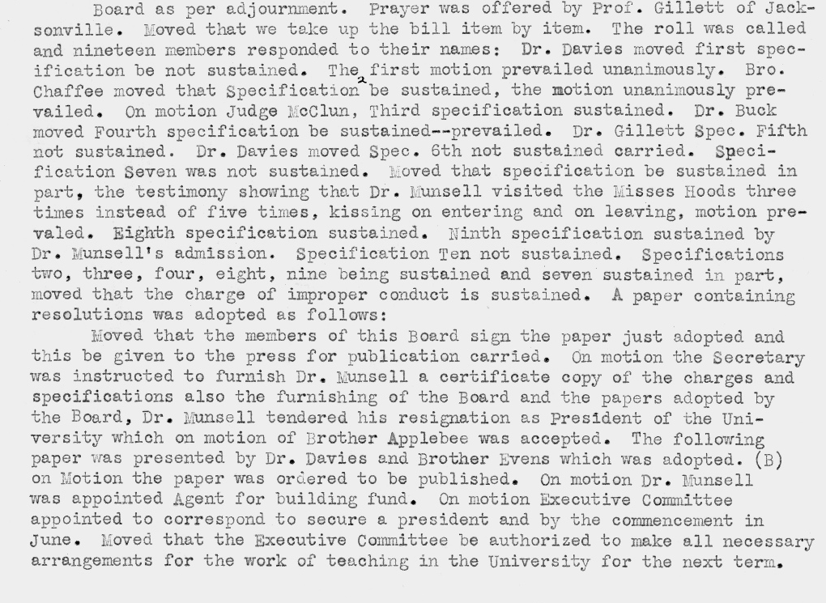

The tally was 5+ sustained, 4 not sustained. Without the motion to sustain spec. 7, after amending the number of Munsell’s visits to the ‘Misses Hood’ from five to three, we would know almost nothing about the nature and substance of any of the charges. Spec. 7 asserted that Munsell had been observed kissing the Hood sisters ‘upon entering and leaving’ what was probably their boarding house in the town. We may with some assurance infer that ‘over-familiarity’ of an affectionate sort was the basis of the other nine specifications. If so, this was more than enough for the Board to expect his resignation from the presidency of Illinois Wesleyan University and for OSM to tender it therewith, which he did, effective immediately, though he was to carry on for a time with the building fund. The ‘certificate copy’ of the charges and verdicts supposedly given to OSM has not turned up. Beyond the ‘kissing the Misses Hood’ and the vague mention of the position of the people on the rostrum at Durley’s Hall,
we know nothing explicit concerning the accusations. Nor is it likely we ever shall.

On Friday, March 28, the Weekly Pantagraph carried a formal communication from the IWU Board of Trustees, signed by all the members, that would be the university’s only public statement on the fate of Oliver S. Munsell:

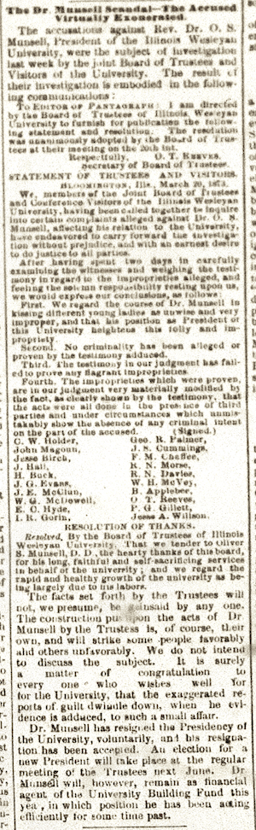

For the sake of clarity, here is the part of the article that gives the Trustees’ statement, as taken from the typescript copy of the minutes:

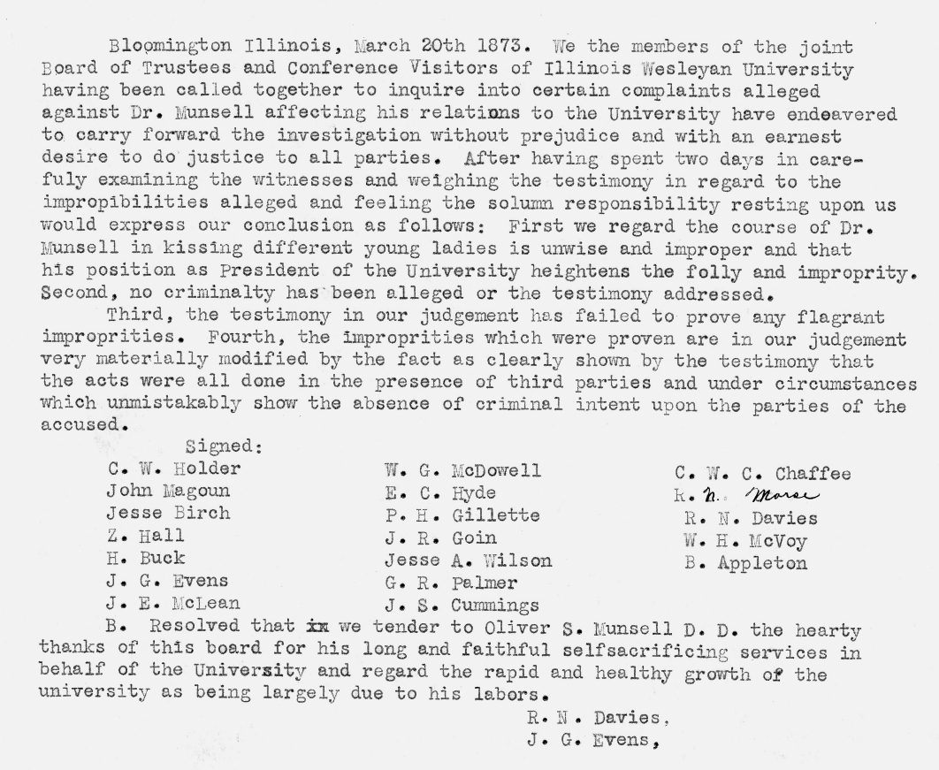

The emphasis in the Trustees’ statement is on the absence of criminality or criminal intent in the ‘unwise and improper’ acts of the ex-president: kissing, sad to say, but no sex, glad to say. To the Weekly Pantagraph Munsell was ‘virtually exonerated’ and all would be well with the university from then on, although Munsell would no longer be a part of it. Civic pride in IWU could continue and grow. The university’s good name was preserved; that of Oliver S. Munsell, however, had been ineradicably stained.

